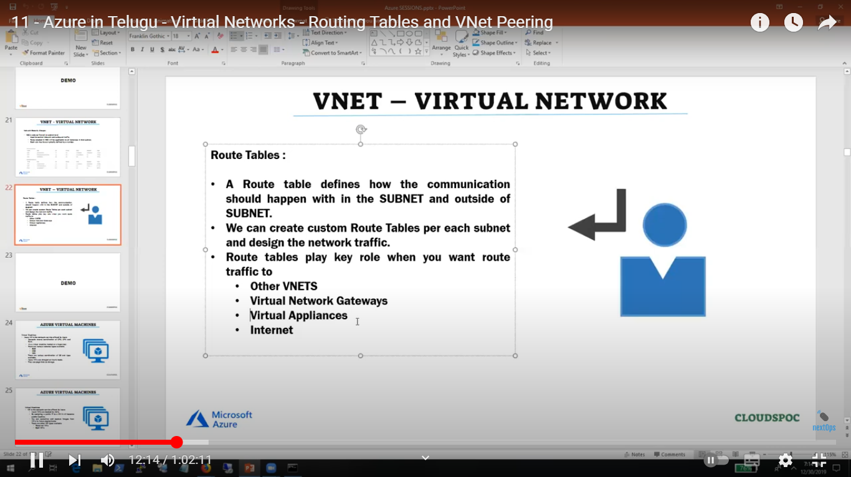

Sn within vn no need rt

https://www.youtube.com/watch?v=gnO2nOs11t4&t=601s